120PC(V) SCCSC 1.1.4 Graphic Organizer:

Radiant Flux, Radiance, Solid Angle and APF

Mr. Hinz

Thomas Stone High School

Radiometry is a system for describing the flow of radiant energy through space.

Solid Angles

One unit of measurement that appears prominently in radiometry is solid angle. This is a generalization of the notion of an angle from 2D to 3D space. In 2D one can think of directions (unit vectors) as being points on the unit circle, and in 3D one can think of directions as being points on the unit sphere. The definition of solid angle is:

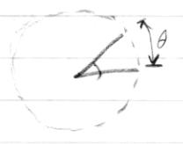

An angle is a section of the unit circle; the mag-nitude (size) of the angle is its arc length.

A solid angle is a section of the unit sphere; the magnitude of the solid angle is its area.

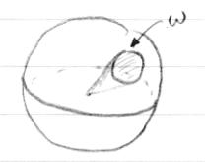The idea of an angle as a set of directions may be new. In 2D the distinction between an angle (the set) and the angle’s magnitude (the number) is a ne one, because as long as the set is connected it is just an interval on the circle. In 3D, the question of the shape of a solid angle is much more interesting, because there can be all sorts of areas on the sphere that have a particular area.

In 2D geometry one talks about the angle subtended by something at another point: for example, the angle at a vertex of a triangle is the angle subtended by the opposite side of the triangle. Similarly in 3D the solid angle subtended by an object is the set of directions that point toward that object.

Radiant Flux

Flux is also known as ___________ ___________.

Power:

Definition: ____________ ______ _______ _______

P is measured in ____________ (W) = ____________/______ (J/s)

Irradiance

Irradiance Definition:

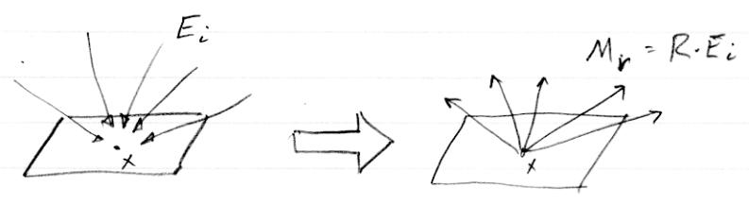

A

In steady state (which we normally assume in graphics) energy and power are basically interchangeable, so we are sometimes a bit sloppy in distinguishing them. When we make a power measurement with some real detector, we get energy captured over some time interval (the exposure). This is an estimate of the instantaneous power: it’s the average power over the exposure.

**Irradiance Formula:**

$$E=\frac{Flux}{O}$$

Radiant Exitance

**Radiant Exitance** or ______________ is light_______________ a surface per unit Area.

**Radiant Exitance Formula:**

$$M=B=\frac{}{}$$

2

Really, radiant ux is the starting point for radiometry; all other radiometric quantities are densities of power.

Flux ____ ________: irradiance E; radiant exitance M (W/m2)

ux per unit area E = d =dA (measured at a point on a surface) synonyms: ___________, B, for radiant exitance

Irradiance is for light arriving at a surface; radiant exitance is for light leaving a surface. Radiosity is radiant exitance but with the _____________________________________________________________. The surface can be real or imagined, but one needs a surface to talk about irradiance.

Flux solid angle density: ____________ I (W/sr)

flux per ____ ______ _______ (measured in a direction)

This concept, in itself, is mostly used with point sources|that is, emitting objects so small that we don’t care about where on the object light is coming from; just what direction it goes in.

n

Flux density wrt. solid angle and area: Radiance L (W/m2sr)

Definition of Flux Density: ___________________________________

L(x; I) is a measure of the density of photons passing near x and traveling in directions near I. The details of \near" are the key to the de nition|this is a geometric question. Radiance measures the radiant ux that would be collected if we look at photons whose directions lie within a solid angle d! around ! and land on an area of surface dA at x that is perpendicular to the direction !.

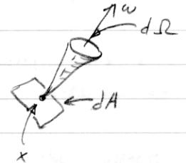

The derivative interpretation: if you enlarge dA or widen d! you will collect more light, and L is the constant of proportionality.

Radiance is a second derivative: It is irradiance (or radiant exitance) per unit solid angle, or it is ___________________________.

3

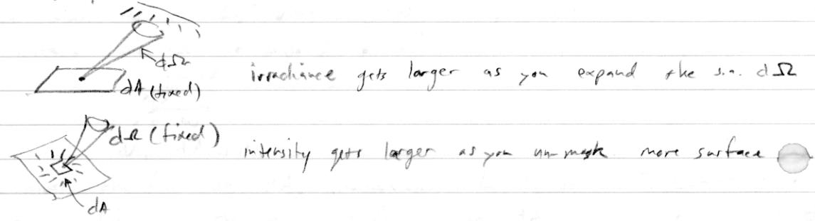

Radiance invariance Radiance is very useful because it is conserved along lines through empty space. That is, if we look at the radiance at two points x1 and x2, in the direction ! that points from one to the other, we will measure the same radiance at both points: L(x1; !) = L(x2; !). To see why this is, we can measure radiance at each point. We can make this measurement using whatever solid angles and areas we want, so let’s choose two areas dA1 and dA2 that are perpendicular to !:

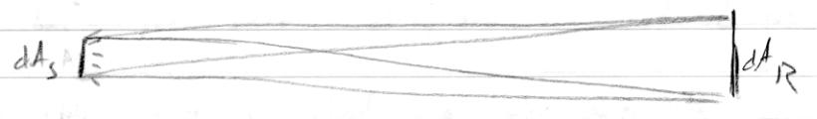

Think of the set of lines connecting these two patches|that is, the set of lines that pass through both rectangles. Along these lines travel all the photons that pass rst through dA1 and then through dA2. To measure radiance at each end, we need to choose solid angles. The trick is to choose the solid angle that exactly corresponds to all directions that pass through the other surface. We de ne d!1 as the solid angle subtended by dA2 from dA1, and likewise d!2 is the solid angle subtended by dA1 from dA2.1 The sizes of these solid angles are

jd!1j = dA1=r2

jd!2j = dA2=r2

Now let d2 be the ux between the surfaces|that is, the energy carried by all the particles that pass rst through dA1 and then through dA2. Because of how we arranged the solid angles for measuring radiance, d2 is the power to be used for measuring radiance on both ends:

|  |  |  |  |  |  |
| --- | --- | --- | --- | --- | --- |
| L1 = | d2 | | L2 = | d2 |  |
| dA1 jd!1j |  | dA2 jd!2j |  |

If we then substitute in the expressions for the sizes of the two solid angles, we end up with

r2d2

L=L=

* You may notice that these solid angles are di erent for di erent points on the surfaces. This is OK because in the limit of small areas the solid angles are all the same.

4

This conservation of radiance means that, in the absence of anything that gets in the way, radiance is really more a property of lines in space than a property of (point, direction) pairs. Finding that dA1 jd!1j = dA2 jd!2j is really just saying that solid angle times area is a well-de ned measure on the space of lines: we can measure the same set of lines in two di erent places and get the same answer (see camera example at end).

Projected area and projected solid angle Our de nitions of radiance are for surface areas perpendicular to the direction in question. What about when we need to work with some other surface, one that’s not perpendicular?

The simple answer: a surface that’s inclined at an angle to ! has the same particles passing through it in the direction ! as a perpendicular surface whose area is smaller by a factor of cos .

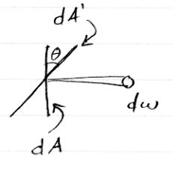

If we call the inclined surface area dA0 and continue to call the perpendicular surface area dA, then dA = dA0 cos . So the radiance can be written

|  |  |  |  |  |  |
| --- | --- | --- | --- | --- | --- |
| L(x; !) = |  | d2 | = | d2 |  |
| dA d! | | dA0 cos d! |  |
|  |  |  |

The presence of the cosine is quite an inconvenience, and hiding it inside a unit of measure is appealing. The two ways of doing this are to group dA0 cos and call it the \projected area" of dA0 in the direction !" or to group d! cos and call it the \projected solid angle."

I nd projected solid angle to be a very handy notational tool, and I will use it heavily as we go on in the course.

* Radiometric units, bottom up

One can also de ne all these quantities by starting with radiance as the basic concept (Preisendorfer calls this \phase space density") and thinking of every-thing else as integrals of radiance. From its de nition it is clear that we can nd power from radiance by integrating over an area and a solid angle:

Z Z

= L(x; !) h!; ni d (!) dA(x)

S

The term h!; ni is the cosine factor to allow for surfaces that are not perpendic-ular to !. The notation d (!) means that the integration variable is ! and the

5

measure we are using is , my name for the solid angle measure on the direction sphere. Similarly dA(x) means that x is the integration variable and area is the measure.

If the surface S is not at, then n is a function of x.

The notation of this integral can be simpli ed by using projected solid angle. I de ne a new measure , called \projected solid angle measure," by giving its relationship to for in nitesimal sets:

(d!) = (d!)h!; ni

There is a nifty geometric way of thinking about this, known as the \Nusselt analog": for any set D in a hemisphere, (D) is the area of the shadow of D on the hemisphere’s base plane:

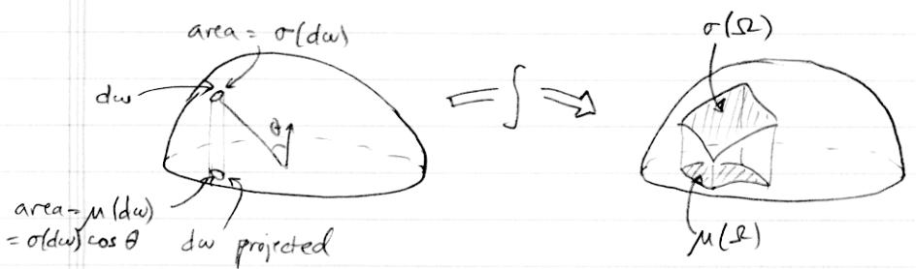

Using projected solid angle measure we can write

|  |  |  |
| --- | --- | --- |
| =ZSZ | L(x; !) d (!) dA(x) | |
| or even just |  |  |
| = ZS | | L d dA |

Doing only the solid angle integral gives irradiance (or radiant exitance):

Z

E(x) = L(x; !) d (!)

Doing only the area integral gives intensity:

Z

I(!) = L(x; !) h!; ni dA(x)

S

We could invent a projected area measure in which to hide the cosine factor, but since this computation is not nearly so common as irradiance, I won’t bother.

* Examples

Detectors for various quantities For some of these quantities it is helpful to think of a detector. For ux, think of a large-area detector (like a photodiode) that just collects all the photons that land on it:

6

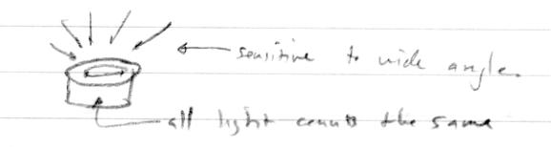

For irradiance, think of a piece of photographic lm. At each point it records a signal that has to do with the density of photons landing near that point, but it does not care about where they come from:

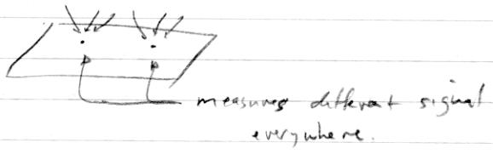

Digital image sensors achieve the same sort of measurement with an array of very small ux meters.

For radiance, the canonical example is a camera or the eye. If we look at a little area in the image (a pixel, say), that collects light arriving at the lens from some solid angle. The aperture of the camera de nes a small area. So the pixel value is an estimate of ux per unit solid angle (in the pixel’s ray direction) per unit area (at the aperture’s position):

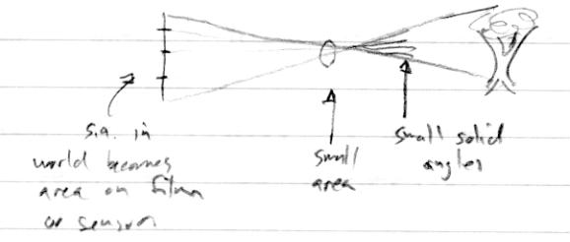

Re ection from perfect di user A perfect di using re ector, known as a Lambertian surface, is a surface that re ects a fraction 0 <= R < 1 of the incoming irradiance (that is, the radiant exitance Mr is R times the irradiance Ei), with uniform radiance Lr in all directions:



7

What is the radiance? We know it’s related to the radiant exitance M:

Z

Mr = Lr(!)d (!)

* 2

Since radiance is constant this is just Mr = Lr (H2) = Lr (use Nusselt analog to see that (H2) = . This means that

R

Lr = Ei

This relationship between re ected radiance and incident irradiance will come up again later when we discuss the BRDF.

Area and solid angle in a camera Here is an example of radiance invari-ance. Suppose I have a camera pointed at a wall 1 meter away, and the camera’s aperture has an area A1 = 1 cm2. Let’s say a single pixel maps to an area A2 = 1 mm2 on the wall. From the camera’s point of view the pixel’s solid angle is

1. 6 sr (remember area over squared distance). From the wall, the camera’s aperture subtends a solid angle of 10 4 sr. If the wall’s radiance is L, the power from A2 that hits the camera’s aperture is = L 10 6m2 10 4srsr. Inter-preting this as a radiance measurement at the camera, we get =10 4m2=10 6sr which is L again.

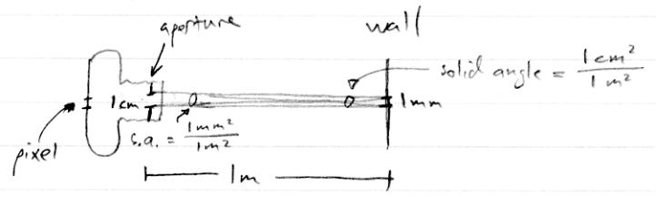

If we point the camera out the window at a mountainside 1 km away, the pixel maps to an area of 1 m2 but the solid angle of the camera from the mountain is only 10 10 sr and if the mountain has the same radiance as the wall we’ll end up with the same power coming into the camera.

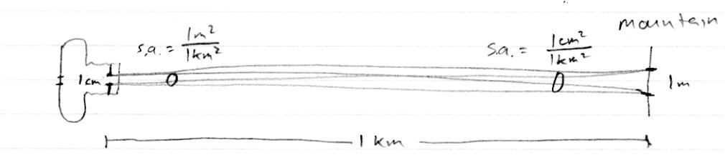

Radiance fallo in a pinhole camera Suppose I make a box with a small hole in one face and a piece of lm on the opposite face. This is a pinhole camera. If we point this camera at a uniform radiance L (say, the overcast sky), what is the irradiance on the lm?

8

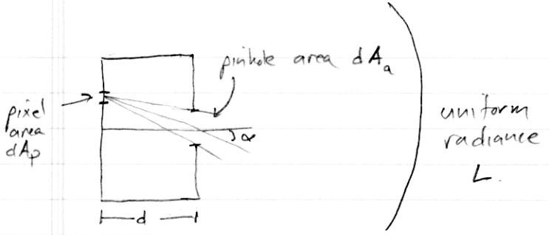

By thinking of a very at box (say a shirt box with the pinhole in the center of the top) it’s obvious that the irradiance is not uniform: it’s bright near the pinhole and dimmer farther away. Furthermore it has to be radially symmetric, so the irradiance is a function of the angle at which the light strikes the lm; call that . Call the distance from the pinhole to the lm d and the area of the aperture dAa.

If we stand on the lm, we see uniform radiance coming from the solid angle subtended by the aperture. This solid angle is

|  |  |  |  |  |  |
| --- | --- | --- | --- | --- | --- |
| dAa cos | | dAa cos3 | |  |  |
| (d!f ) = |  | = |  |  |  |
| r2 | d2 |  |  |
|  |  |  |  |

|  |  |  |  |
| --- | --- | --- | --- |
| The irradiance is L times (d!f ), which is | |  |  |
| Ef = | LdAa cos4 |  |  |
| d2 |  |  |
|  |  |  |

So the irradiance is proportional to the square of the aperture (no surprise there), drops o with the square of the pinhole distance (no surprise there), and also drops o toward the corners of the image as the fourth power of cos . This turns out also to be true of a camera made with an ideal lens.

Resolved and unresolved objects in images When we point a camera at an object, we think of the camera as recording that object’s radiance. This means that if we move the camera closer to or farther from the object the pixel value stays the same. This is only true if the radiance is constant over the pixel|that is, if the object is big enough to be resolved by the pixel grid:

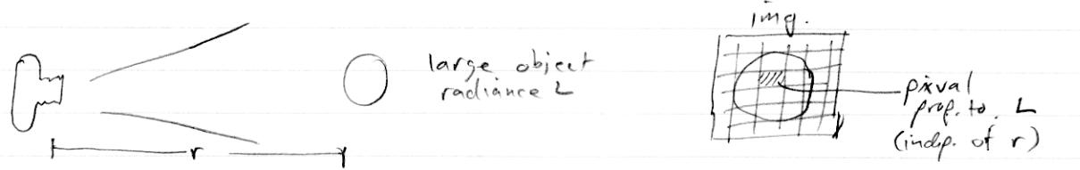

If the object is small and/or far away (a droplet of water, a star, etc.) so that it falls entirely within one pixel, then it behaves a bit di erently. It’s no longer

9

possible to tell the radiance from the pixel value, and the pixel value doesn’t stay the same with distance. Instead, the value is related to the intensity of the object, not the radiance, and it falls o with distance squared:

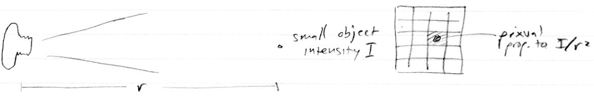

10